* [Insert some data into a table](https://pgexercises.com/questions/updates/insert.html)

insert into cd.facilities

(facid, name, membercost, guestcost, initialoutlay, monthlymaintenance)

values (9, 'Spa', 20, 30, 100000, 800);

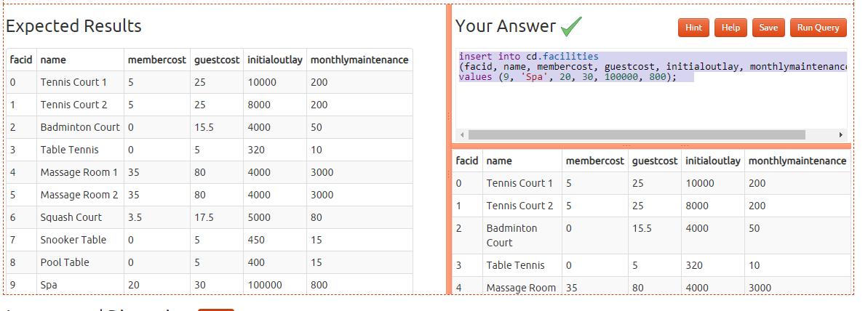

* [Insert multiple rows of data into a table](https://pgexercises.com/questions/updates/insert2.html)

insert into cd.facilities

(facid, name, membercost, guestcost, initialoutlay, monthlymaintenance)

values

(9, 'Spa', 20, 30, 100000, 800),

(10, 'Squash Court 2', 3.5, 17.5, 5000, 80);

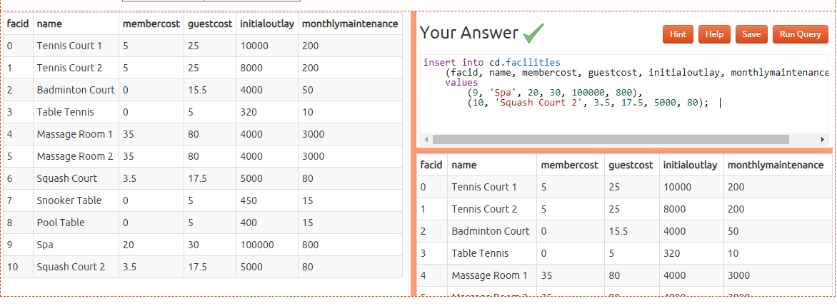

* [Insert calculated data into a table](https://pgexercises.com/questions/updates/insert3.html)

insert into cd.facilities

(facid, name, membercost, guestcost, initialoutlay, monthlymaintenance)

select (select max(facid) from cd.facilities)+1, 'Spa', 20, 30, 100000, 800;

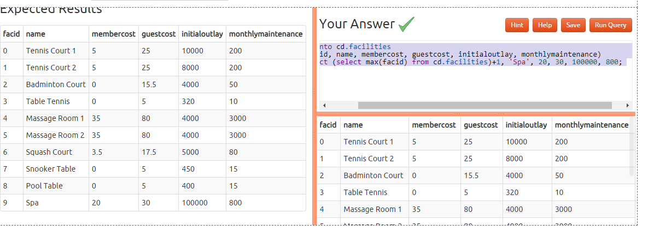

* [Update some existing data](https://pgexercises.com/questions/updates/update.html)

UPDATE cd.facilities set initialoutlay =10000 where facid=1; 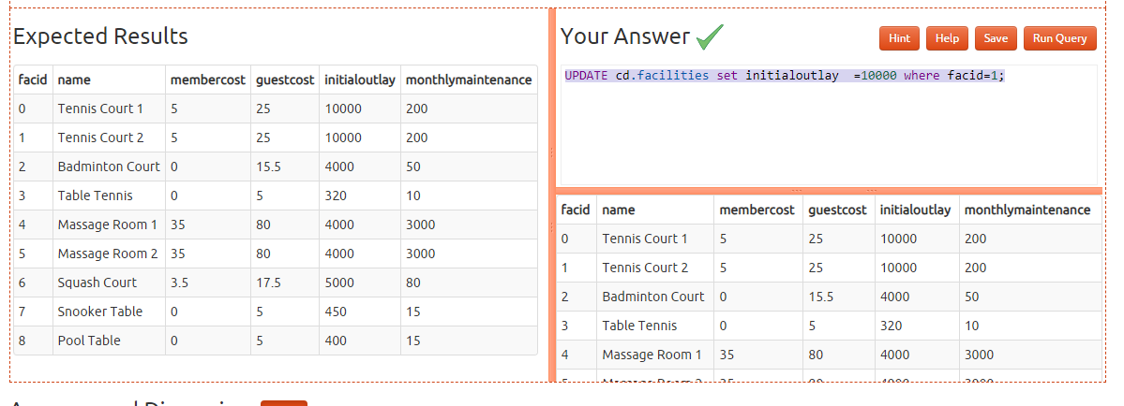

* [Update multiple rows and columns at the same time](https://pgexercises.com/questions/updates/updatemultiple.html)

update cd.facilities set membercost = 6,guestcost = 30 where facid in (0,1); 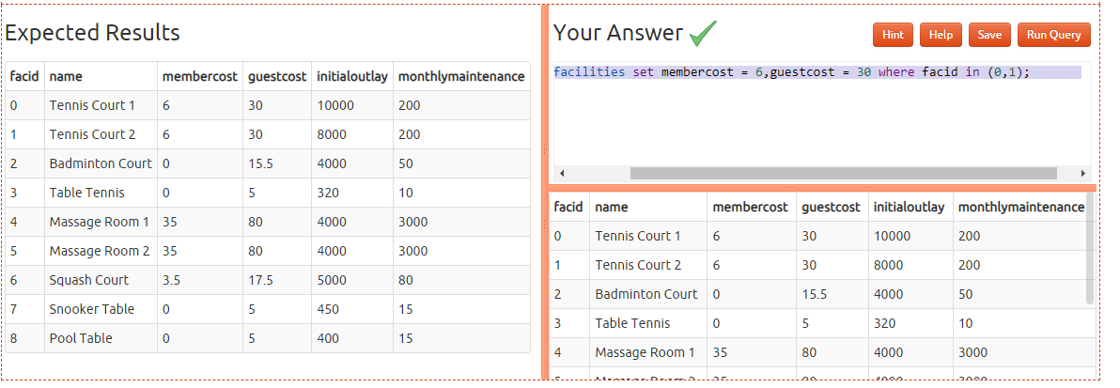

* [Update a row based on the contents of another row](https://pgexercises.com/questions/updates/updatecalculated.html)

update cd.facilities facs

set

membercost = (select membercost * 1.1 from cd.facilities where facid = 0),

guestcost = (select guestcost * 1.1 from cd.facilities where facid = 0)

where facs.facid = 1;

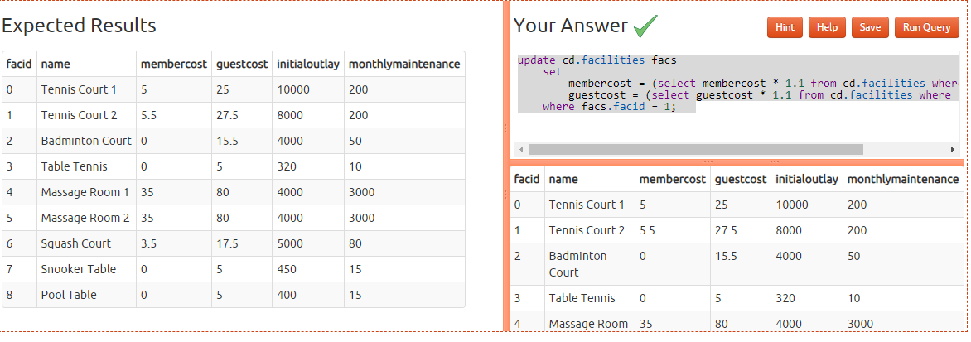

* [Delete all bookings](https://pgexercises.com/questions/updates/delete.html)

delete from cd.bookings; 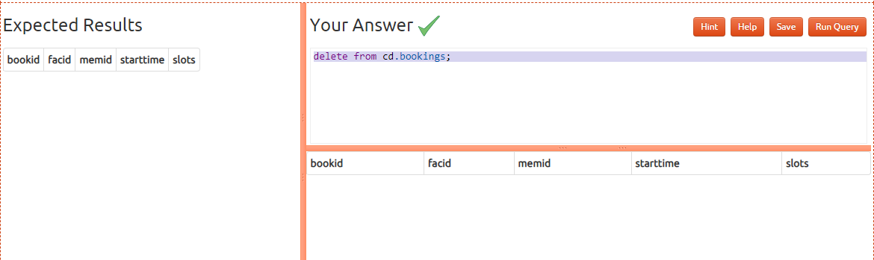

* [Delete a member from the cd.members table](https://pgexercises.com/questions/updates/deletewh.html)

delete from cd.members where memid=37;

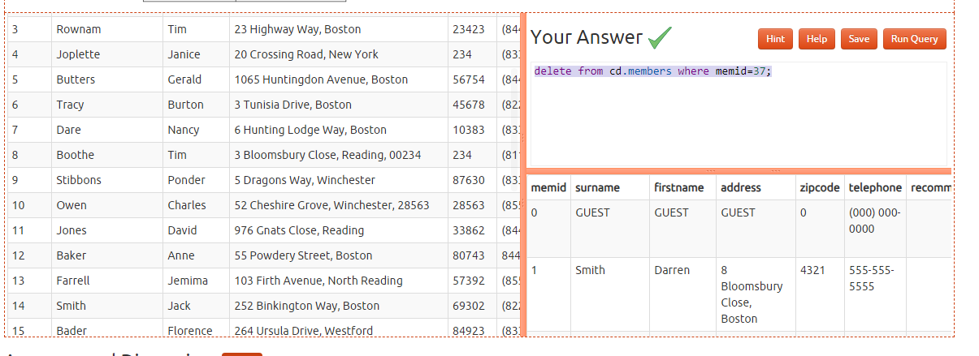

* [Delete based on a subquery](https://pgexercises.com/questions/updates/deletewh2.html)

delete from cd.members where memid not in (select memid from cd.bookings);

